MACHINE LEARNING IN

Mr. Thomas Mathew Department of Computer Sciences Santhigiri College of Computer
Sciences Thodupuzha, Idukki
thomasmathew@santhigiricollege.ac.in
Ms. Adithya Ramanan
Assistant Professor
Department of Computer Sciences Santhigiri College of Computer Sciences Thodupuzha, Idukki adithyaramanan@santhigiricollege.ac.in

Abstract - Automatic Speech Recognition (ASR) has evolved significantly with advances in machine learning and deep learning. Recently, Audio-Visual Speech Recognition (AVSR) has emerged as a robust alternative by incorporating visual cues to handle noisy environments. This seminar report presents a comparative analysis of two representative research works: (i) Automatic Speech Recognition: A Systematic Literature Review and (ii) Leveraging Modality-Specific Representations for Audio-Visual Speech Recognition via Reinforcement Learning. The comparison focuses on objectives, methodologies, datasets, performance, advantages, limitations, and applicability. The study highlights how AVSR with reinforcement learning overcomes several limitations identified in traditional ASR systems.

Keywords — Automatic Speech Recognition, Audio-Visual Speech Recognition, Deep Learning, Reinforcement Learning, Noise Robustness

INTRODUCTION
Speech recognition is a key technology enabling natural human–computer interaction. Traditional ASR systems rely solely on acoustic signals, making them sensitive to noise, speaker variability, and environmental conditions. To address these challenges, researchers have explored multimodal approaches, especially AVSR, which integrates visual information such as lip movements. This seminar compares a systematic ASR survey paper with a recent AVSR research paper to understand theoretical foundations and practical advancements.
The objective is to compare a traditional Automatic Speech Recognition (ASR) system with an advanced Audio-Visual Speech Recognition (AVSR) system, focusing on their methodologies, performance, noise robustness, advantages, limitations, and real-world applicability.
- LITERATURE REVIEW

Paper 1: “Automatic Speech Recognition: Systematic Literature Review”

This paper provides a comprehensive review of ASR research published between 2015 and 2020. It follows the PRISMA protocol to systematically analyze 82 high-quality research articles. The study identifies major ASR research topics, challenges, datasets, and future research directions. It emphasizes issues such as noise robustness, accent variability, vocabulary size, and dataset limitations.

The paper analyzes and summarizes the technologies used in ASR research during 2015–2020.
- Traditional ASR Technologies (HMM, GMM, MFCC etc...)
- Machine Learning Techniques (SVM, Decision trees, KNN etc.)
- Deep Learning Technologies (DNN, CNN, RNN etc.)
- End-to-End ASR Models (CTC, Attention-based Encoder–Decoder models, RNN-Transducer (RNN-T)
- Noise Robustness & Signal Processing Techniques (Speech enhancement, Noise reduction algorithms, Feature normalization (CMVN), Beamforming etc...)
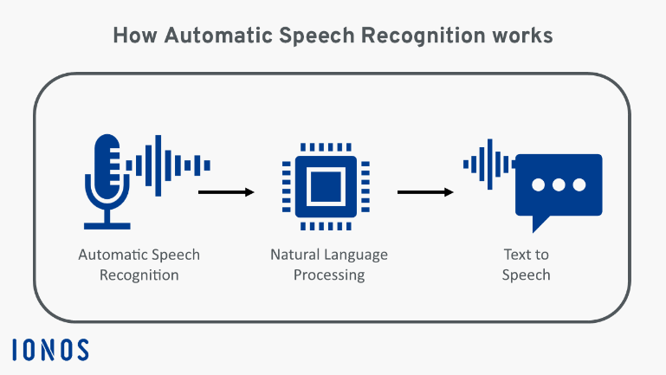
Figure1: ASR Steps

Paper 2: Enhancing Gene Mutation Prediction with Sparse Regularized Autoencoders in Lung Cancer Radiomics
This paper proposes a novel AVSR framework called MSRL, which dynamically integrates modality-invariant and visual modality-specific representations using reinforcement learning. The system improves speech recognition performance under noisy conditions by adaptively weighting audio and visual inputs during decoding. Experimental results on the LRS3 dataset demonstrate state-of-the-art performance in both clean and noisy environments. give me this paper used models and technology. Models and Technologies Used in the MSRL Paper: -
- Audio-Visual Speech Recognition (AVSR)
Combines audio signals and visual lip-movement information to improve recognition in noisy environments.
- Reinforcement Learning:( Policy NetworkRLAlgorithm)
- Deep Learning Models Used.
- ResNet (Residual Neural Network)
- Pre-trained Models(AV-HuBERT,Pre-trained Vision (Lip-Reading) Model
- Reinforcement Learning(Policy Network, RL Algorithm)
- Feature Representation Types(Modality-Invariant Representations, Modality-Specific Representations)

COMPARATIVE ANALYSIS

Algorithm / Methodology | Paper 1: ASR Survey | Paper 2: MSRL-based AVSR
1. Feature Extraction | MFCC, LPC, filter-bank features for audio | ResNet extracts features from audio spectrograms and visual lip frames
2. Sequence Modeling | Hidden Markov Models (HMM) for temporal speech sequences | Transformer Encoder–Decoder with attention mechanisms
3. Deep Learning Models | DNN, CNN, RNN/LSTM for acoustic modeling | Transformer + Reinforcement Learning for adaptive fusion
4. End-to-End Recognition | CTC and attention-based encoder-decoder ASR | Auto-regressive AVSR decoding with modality-invariant & visual-specific representations
5. Performance Evaluation | Word Error Rate (WER) trends across datasets | Word Error Rate (WER) on LRS3, optimized via RL and beam search

- KEY ALGORITHMS & METHODOLOGIES

From Paper 1 (Survey)
- Feature Extraction (MFCC):
Extracts important speech characteristics for recognition.
- Hidden Markov Models (HMM):
Models temporal speech sequences in traditional ASR systems.
- Deep Neural Networks (DNN):
Improves acoustic modeling accuracy over GMM-based methods.
- Recurrent Neural Networks (RNN/LSTM):
Captures long-term temporal dependencies in speech signals.
- End-to-End ASR Models (CTC / Attention):
Directly map speech input to text output with reduced system complexity.

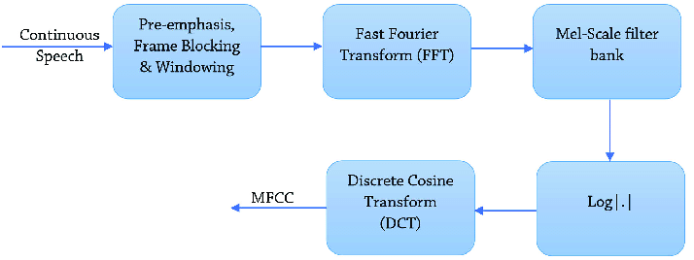

Figure 2:MFCC Steps[1]

From Paper 2 (Research)
- Audio-Visual Speech Recognition (AVSR):
Combines audio signals with visual lip-movement information for robust speech recognition.
- Transformer-Based Encoder–Decoder:
Used for sequence modeling and speech-to-text conversion with attention mechanisms.
- ResNet Feature Extraction:
Extracts high-level features from audio spectrograms and visual lip frames.
- Reinforcement Learning (Policy Gradient):
Dynamically weights modality-invariant and visual-specific representations during decoding.
- Beam Search Decoding with WER Optimization:
Improves transcription accuracy and evaluates performance using Word Error Rate.

OPPURTUNITIES
- Noise-Robust Speech Recognition: Audio-visual models improve recognition accuracy in noisy environments by combining audio signals with visual lip-movement information.
- Multimodal Data Integration: Fusion of audio and visual modalities enhances system reliability compared to traditional audio-only ASR systems.
- Adaptive Learning Systems: Reinforcement learning enables dynamic weighting of modalities, allowing systems to adapt to changing environmental conditions.
- Real-Time Human–Computer Interaction: Improved ASR/AVSR systems support real-time voice assistants, smart homes, and interactive robotic applications.
- Assistive Technologies: AVSR provides effective communication support for hearing-impaired users through visual speech cues.
Low-Resource Language Support: Advanced learning techniques reduce dependency on large datasets, enabling speech recognition for low-resource languages and accents.

- Automated Speech Processing: Reduces manual transcription effort and human errors in applications such as call centers and media captioning.

CHALLENGES
- Data Scarcity & Annotation Cost: Large,
- accurately labeled speech and audio-visual datasets are expensive and time-consuming to create.
- Noise and Environmental Variability: Background noise, reverberation, and real-world conditions still degrade ASR performance.
- High Computational Cost: Deep learning, Transformer models, and reinforcement learning require high processing power and memory.
- Model Complexity: AVSR systems involve multiple networks (audio, visual, fusion, RL), increasing system complexity and training difficulty.
- Generalizability: Models trained on one dataset may not perform well on others.
- Real-Time Deployment Constraints:
Latency and resource limitations make it difficult to deploy AVSR models on edge or mobile devices.
- Privacy & Ethical Concerns: Use of visual data (lip movements, faces) raises privacy and security issues in real-world applications.

CONCLUSION & FUTURE DIRECTIONS

This study compared a systematic review of Automatic Speech Recognition (ASR) with a reinforcement learning–based Audio-Visual Speech Recognition (AVSR) approach. While the ASR review established theoretical foundations and identified key challenges, the MSRL-based AVSR model demonstrated improved performance through visual integration and adaptive learning. Together, the papers highlight the shift from audio-only ASR to robust, multimodal speech recognition systems.
This comparative study highlights:
- The strengths and limitations of traditional audio-only ASR systems.
- The effectiveness of audio-visual integration in improving speech recognition accuracy.
- The role of reinforcement learning in adaptive and noise-robust AVSR systems.
- The transition from theoretical ASR research to practical multimodal applications.
- The potential of AVSR for real-world, noisy, and low-resource environments.
Future Directions:
- Enhanced Multimodal Fusion: Explore advanced fusion strategies that integrate audio, visual, and contextual information.
- Lightweight and Efficient Models: Develop computationally efficient AVSR models suitable for mobile and edge devices.
- Low-Resource Language Support: Extend ASR and AVSR systems to underrepresented languages and accents.
- Self-Supervised and Transfer Learning: Reduce reliance on labeled data through pre-training and transfer learning.
- Real-World Deployment and Evaluation: Validate systems in real-life environments such as classrooms, healthcare, and public spaces.

REFERENCES

